Game Concept Design - Neon Orange

# Overview

Neon Orange is a game about skating through a city at breakneck speed on your laserboard. The game combines fast paced action, with precision platforming as you make your way from the city rooftops to the underground sewers, all the while performing sick tricks.

A 2D skating game where everything is a glowing neon orange. You skate through a neon city-scape with heavy emphasis on the tight controls. The game starts at the top of a slope, with a view of the city you are about to go through behind you. As you go down you can perform tricks off things like stair rails, ramps, walls, and anything in the environment.

# Core Experiences/Game Pillars

* Retro Neon Aesthetic
  + Art, Music, and gameplay all in sync
  + Fully immerse the player
* Responsive Controls
  + Key to the platforming genre
  + Makes the game fair and about skill
* Fast and Fluid Gameplay
  + Key to the core experience
  + Keeps the player engaged with gameplay that isn’t too hard for mid-core gamers, but also appeals to core gamer’s need for a tough challenge

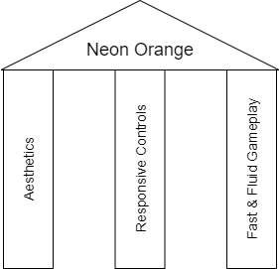

# Gameplay Aspects

## Mechanics

Movement

* Push forward/backward to accelerate/decelerate
* Full directional control in air - can rotate for landings and tricks
* Player falls off the board if it is more than 45 degrees perpendicular to surface (when landing)
* Can push off walls/wall jump

Boost

* Speeds up board and AI disintegration
* Fills up with boost capsules

AI

* Simple AI characters that run from you
* Player’s skateboard disintegrates AI when contacted

Obstacles

* Objects that must be ramped over
* Walls that must be boosted through
* Alleyways where you must wall jump and boost out

Score

* A separate score for each level that denotes completion
* Is increased through completing different things within the level such as:
  + Taking different paths
  + Getting all collectibles
  + Performing specific tricks
* Unlocks different things like:
  + Different colours
  + Secret levels

## Rules

* If the player falls off the board the retry/quit pop up appears
* Player cannot stop moving, only slow themselves
* You cannot boost if the bar is empty
* You win when reaching the end of the stage

## Loop

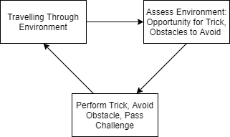

# Unique Selling Point

A game about what it would feel like to skate through a city on a lightsaber.

# Target Platform

It is a simple enough game which would be best played with joysticks but can still be played with a keyboard. Only released on digital stores so no physical production.

* PC
  + More indie friendly
* Consoles
  + PlayStation/Xbox/Nintendo

# Evidence of Design

Full prototype game map:

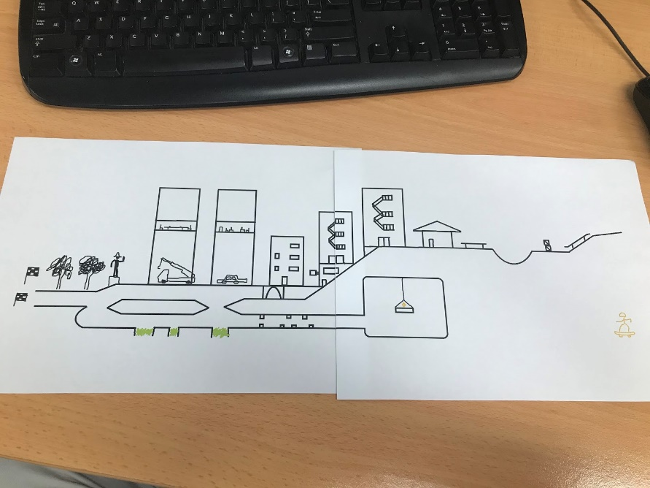

Initial Prototype:

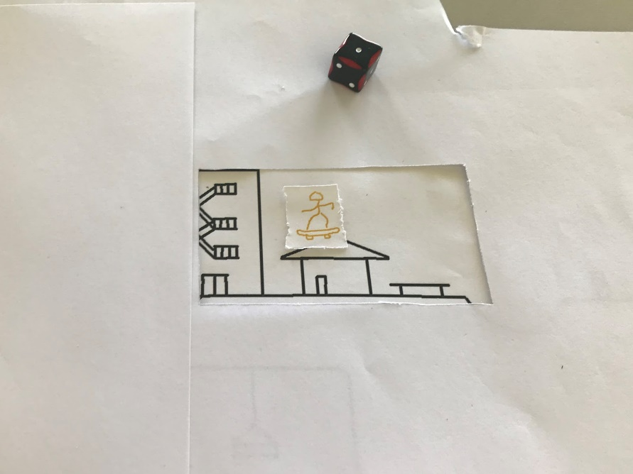

Initial prototype was performed with a game-like view, and the player was told where they could jump to. A die was rolled and 1 meant failing, where 6 meant a trick. Tricks gave 100 points, with 50 extra points being added for every trick after.

This design succeeded in being fast paced, but the constricted view did not let the player make decisions and explore the map to its fullest. It did not reflect the game very well and was completely up to chance with very little player interaction.

First iteration:

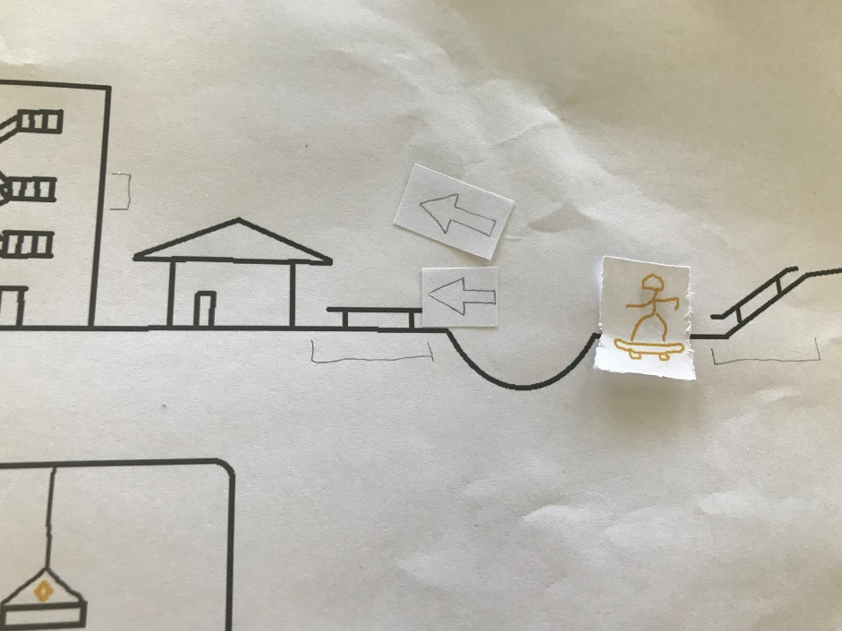

The game map was revealed to the player and it was clearly indicated where the player could branch off and perform tricks. The player could now choose whether to do a trick or not, and if they chose to trick a D6 would be thrown with 1 being fail. The goal was to get the most points, with the player getting 100 for a trick and 200 for a consecutive one.

The first iteration encouraged the player to explore the map more, and succeeded in doing so. It also reflected the game better in the way that you can perform risky tricks that give more points but also increase the chance of failure. The consecutive trick multiplier had the desired effect of making the tricks valuable to the player as multiple play testers pushed the limit of probability.